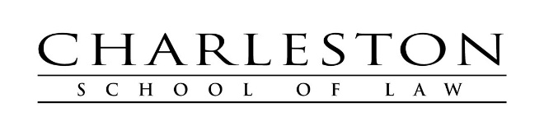
PRO BONO REQUIREMENT CERTIFICATION FORM

Students matriculating before June 2019 are required to complete 30 hours of pro bono legal service before graduation. Students matriculating on or after June 2019 are required to complete 50 hours of pro bono legal service before graduation. All May graduates must complete their requirement by April 1 of their graduation year. All December graduates must complete their requirement by November 1 of their graduation year.

Dean Larry Cunningham or the Director of Public Service and Pro Bono Michelle Mensore Condon must approve pro bono work to qualify. Please complete this form and return it to Sandra Restrepo on the second floor of 385 Meeting Street. You also may send the form by fax to 843-377-4055 or by e-mail to srestrepo@charlestonlaw.edu. If necessary, use additional sheets. Be sure to turn in all your pro bono hours, even beyond the requirement. Please write legibly with ink or type.

___________________________________________ _______________
Student name Month/ Year of Graduation FT PT
(Please circle)

_____
Name of company or organization Dates worked MM/DD/YY # Hours # hours

Address City State Zip

Name of project or client matter

Supervising attorney signature and printed name Telephone number

_____
Name of company or organization Dates worked MM/DD/YY # Hours # hours

Address City State Zip

Name of project or client matter

Supervising attorney signature and printed name Telephone number

Date form submitted.

